N8N Workflow for AI Agent tool for scheduling doctor’s appointments.

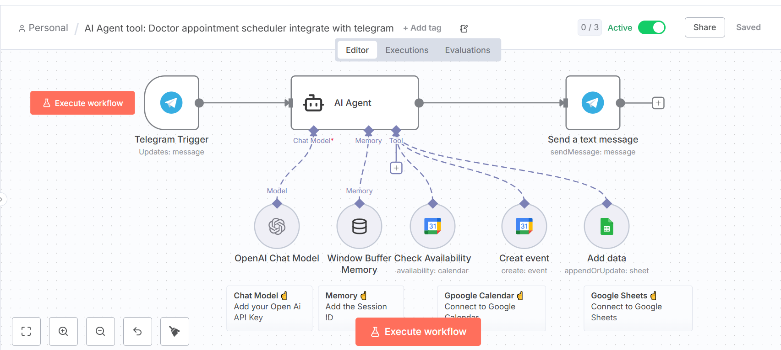

Google calendar entry 👍

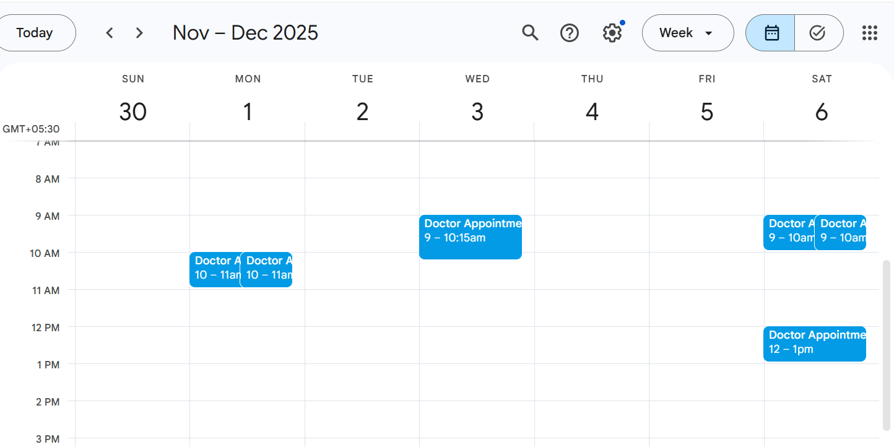

Google sheet sample entry

